**Traffic Sign Detection App**

**Software Architecture**

**Version 1.1**

**Team Members:**

Hayden Jones

Shreya Komarabattini

Rishigesh Rajendrakumar

Aidan Mao

Jacob Heffelmire

Revision History

|  |  |  |  |
| --- | --- | --- | --- |
| **Date** | **Version** | **Description** | **Name** |
| 10/3/25 | 1.0 | First draft | Hayden Jones |
| 12/5/25 | 1.1 | Final Draft | Rishigesh Rajendrakumar |

System Model:

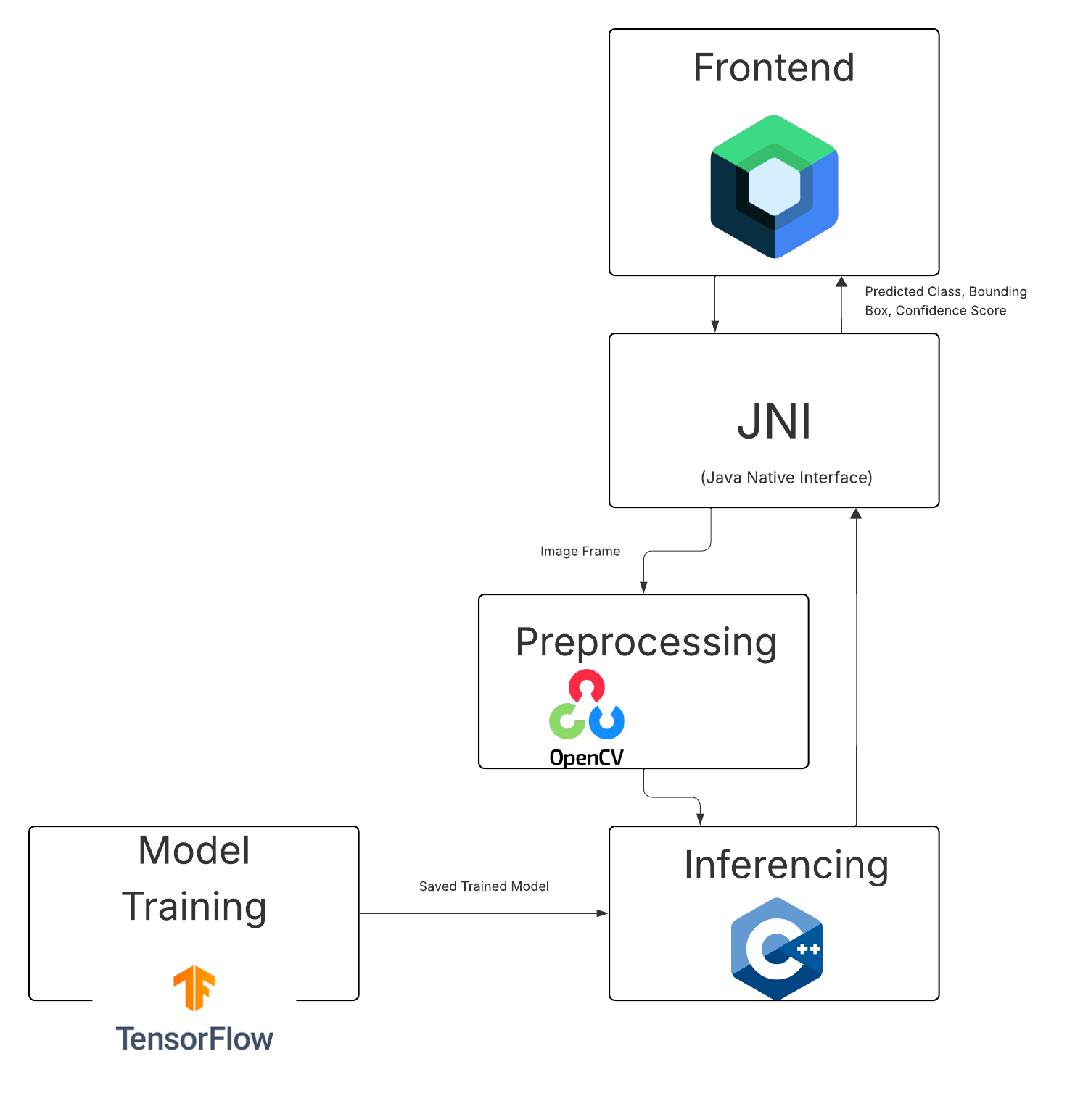

YOLO Architecture Model:

